24SDCS02 / 24SDCS02E / 24SDCS02P / 24SDCS02L – FSAD WORKBOOK
DEPARTMENT OF CSE, CS&IT, AI&DS
COURSE CODE: 24SDCS02 / 24SDCS02E / 24SDCS02P / 24SDCS02L
FULL STACK APPLICATION DEVELOPMENT
Date of the Session: / Time of The Session

#SKILL - 5 Spring Autowiring Demo using @Autowired
Prerequisites:
- General Idea on Spring Framework
- Modules of Spring Framework
- Understanding of Autowiring concepts

A college application maintains student information along with their certification details. The Student object contains a Certification object, and instead of creating this Certification object manually, Spring should automatically provide it using the @Autowired annotation. When the required classes are marked with @Component, Spring creates their objects and manages them inside the IoC container. Using @Autowired, the Certification object is supplied to the Student object by Spring without using the new keyword, allowing both objects to be linked through annotation-based configuration.

Tasks:
- Create a Certification class with fields such as id, name, and dateOfCompletion.
- Create a Student class with fields such as id, name, gender, and a Certification object.
- Annotate both classes with @Component to enable Spring detection.
- Use @Autowired on a field, constructor, or setter inside the Student class to inject the Certification object.
- Configure component scanning using either:
  - An XML configuration file
  - A Java configuration class with @Configuration and @ComponentScan
- Load the Spring IoC container using ApplicationContext.
- Retrieve the Student bean and print all details, including the injected Certification object.
- Push the Spring project to GitHub.

Project Structures
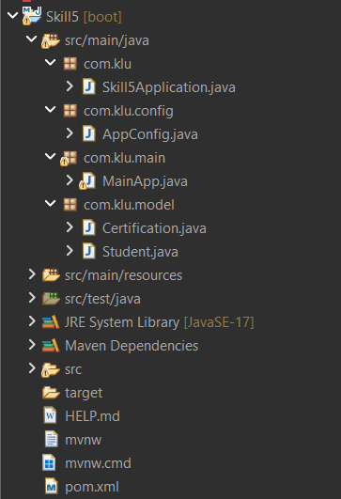
Programs
Application.java
package com.klu;

import org.springframework.boot.SpringApplication;
import org.springframework.boot.autoconfigure.SpringBootApplication;

SpringBootApplication
public class Skill5Application {

public static void main(String[] args) {
SpringApplication.run(Skill5Application.class, args);
}

}
Config.java
package com.klu.config;

import org.springframework.context.annotation.ComponentScan;
import org.springframework.context.annotation.Configuration;

@Configuration
@ComponentScan(basePackages = "com.klu")
public class AppConfig {
}
MainApp.Java
package com.klu.main;

import org.springframework.context.ApplicationContext;
import org.springframework.context.support.ClassPathXmlApplicationContext;
import com.klu.model.Student;

public class MainApp {

public static void main(String[] args) {

ApplicationContext context =
new ClassPathXmlApplicationContext("applicationContext.xml");

Student student = context.getBean(Student.class);
student.displayDetails();
}
}
Certification.java
package com.klu.model;

import org.springframework.stereotype.Component;

@Component
public class Certification {

private int id;
private String name;
private String dateOfCompletion;

public Certification() {
this.id = 101;
this.name = "Java Full Stack";
this.dateOfCompletion = "15-01-2025";
}

@Override
public String toString() {
return "Certification [id=" + id +
", name=" + name +
", dateOfCompletion=" + dateOfCompletion + "]";
}
}
Student.java
package com.klu.model;

import org.springframework.beans.factory.annotation.Autowired;
import org.springframework.stereotype.Component;

@Component
public class Student {

private int id;
private String name;
private String gender;

@Autowired
private Certification certification;

public Student() {
this.id = 1;
this.name = "maha";
this.gender = "Female";
}

public void displayDetails() {
System.out.println("Student ID : " + id);
System.out.println("Student Name : " + name);
System.out.println("Gender : " + gender);
System.out.println("Certification : " + certification);
}
}
ApplicationContext.xml
<?xml version="1.0" encoding="UTF-8"?>
<beans xmlns="http://www.springframework.org/schema/beans"
xmlns:xsi="http://www.w3.org/2001/XMLSchema-instance"
xmlns:context="http://www.springframework.org/schema/context"
xsi:schemaLocation="
http://www.springframework.org/schema/beans
http://www.springframework.org/schema/beans/spring-beans.xsd
http://www.springframework.org/schema/context
http://www.springframework.org/schema/context/spring-context.xsd">

<!-- Scan SAME base package -->
<context:component-scan base-package="com.klu"/>

</beans>

Output screenshorts

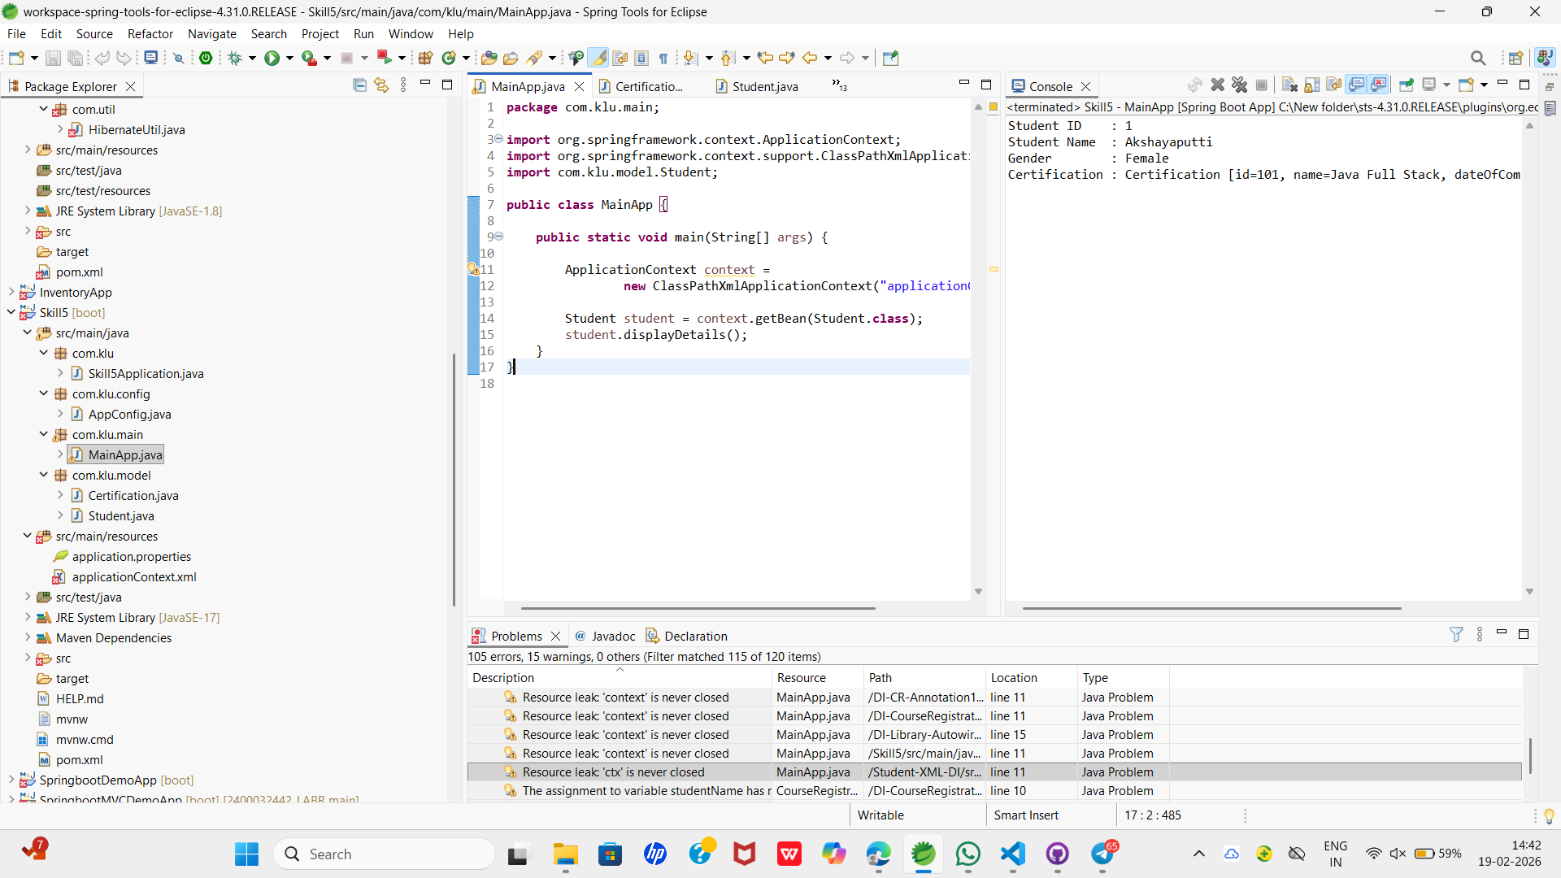


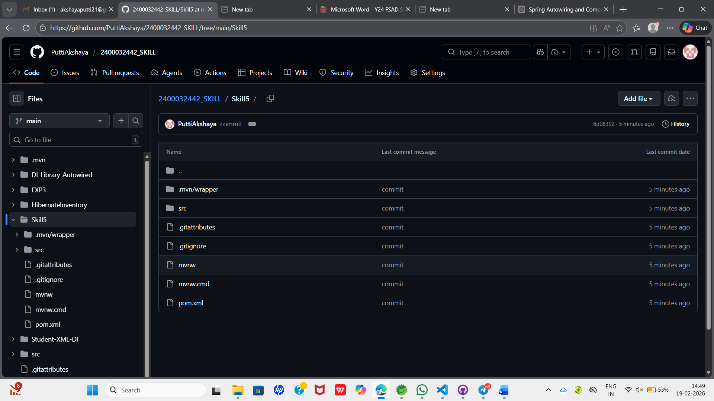

VIVA QUESTIONS :
1. What is autowiring in Spring?
Autowiring is a feature in Spring Framework that automatically injects required dependencies into a bean.

2. What is the purpose of the @Autowired annotation?
@Autowired tells Spring to automatically find and inject a matching bean.

3. How does Spring choose which bean to inject?
Spring injects a bean based on matching type, and if needed, by name.

4. What is component scanning in Spring?
Component scanning automatically detects and registers annotated classes as beans.

5. What happens if more than one bean matches the dependency type?
Spring throws an exception unless you specify which bean to use (e.g., with @Qualifier).

Comment of the Evaluator (if Any)

Evaluator’s Observation
Marks Secured: out of
EMP ID & Full Name of the Evaluator:

Signature of the Evaluator Date of Evaluation:

